Table of Contents

1. Executive Summary 3
1. Confidentiality 4
2. Legal Disclaimer 4
4. Recommended Immediate and Long-Term Changes 5
5. Scope 5
Scope Exclusions 6
6. Network Topology 7
7. Testing Methodology 7
8. Risk Assessment Methodology 8
9. Assessment Findings 9
10. Conclusion 27
Appendix A: Account Credentials 28
Passwords Recovered for Users (Example) 28
Appendix B: Tools 29
Appendix C: Acronyms Used 29

Executive Summary
All Ports Tours is a growing competitor in the luxury cruise and commercial sector, offering “unforgettable adventures” and “sunsets as a service”. During the COVID pandemic, All Ports Tours experienced significant downtime in which they invested heavily in guest-focused digital upgrades and current systems enhancements. These upgrades improved the guest experience but also postponed routine security testing and system audits. This assessment aims to identify existing vulnerabilities and reinforce the security controls that protect critical assets.
Given the importance of securing user information and maintaining operational integrity, the findings in this report represent a critical step in fortifying Butters Family Farm’s infrastructure against potential threats, thereby ensuring a safe and reliable experience for its expanding user base.
This comprehensive penetration test was performed to determine the security and resilience of Butters Family Farm’s infrastructure, spanning user data management, application security, and network defenses essential to Butters Family Farm’s functionality, beginning on November 7, 2026, 10:00 AM EST and concluding on November 7, 2026, 6:00 PM EST. The final report was delivered on November 7, 2026, at 11:59 PM EST.
During our assessment of Butters Family Farm’s assets, we found X vulnerabilities: X critical, X high, X moderate, X low, and X informational. The top critical vulnerabilities include [list top critical vulnerabilities briefly]. To maintain data confidentiality, integrity, and availability, Butters Family Farm should implement the recommended changes outlined in our security assessment findings to address and resolve these identified vulnerabilities.
Leaving these systems in their current state will expose them to the risk of an intrusion, leading to severe fines, legal consequences, and loss of consumer trust. It is highly recommended that Butters Family Farms further review the detailed list of vulnerabilities in this document and begin remediation immediately.
Severity | Number of Vulnerabilities
Informational
Low
Moderate
High
Critical
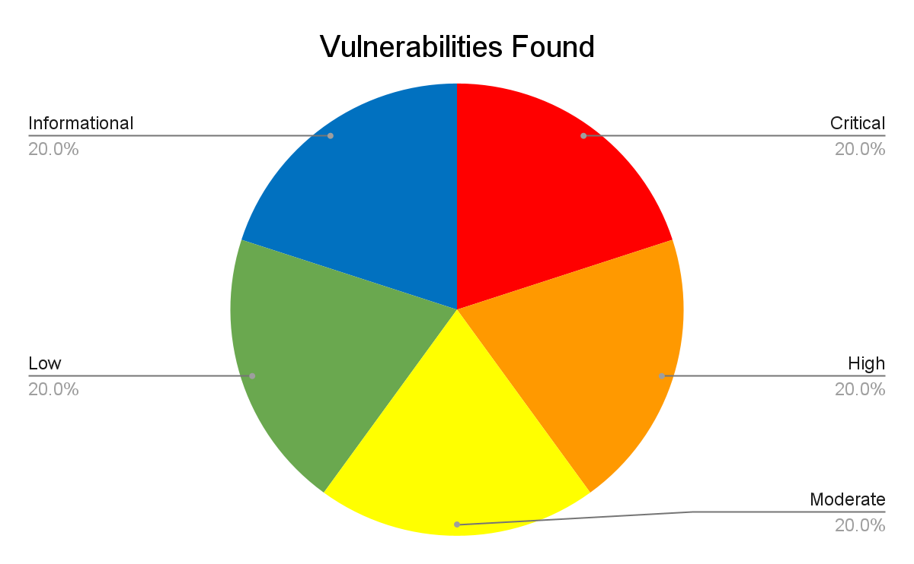

Confidentiality
This document and all information contained within are confidential and proprietary to Southeast Team XX and Butters Family Farm. Extreme care should be exercised when handling, referring to, or copying this document. Extreme care should be exercised when handling, referring to, or copying this document. Southeast Team XX authorizes Butters Family Farm to view and disseminate this document as they see fit in accordance with Southeast Team XX’s data handling policies. Further dissemination of this document should be marked as “CONFIDENTIAL'' and viewed internally on a “need-to-know” basis.

Legal Disclaimer
In no event shall Southeast Team XX be liable for the incidental, collateral, or consequential damages that occur through the use of this information in replication and remediation. All information presented throughout this document is provided as-is and without warranty. Penetration tests and vulnerability assessments are a “point-in-time” analysis, and as such, any changes to the environment or discoveries made in vulnerability research after this assessment will result in this assessment becoming obsolete as time passes.

Recommended Immediate and Long-Term Changes //CHANGEME
Listed below are observations US-Southeast-X made while conducting the vulnerability assessment within Butters Family Farm to mitigate current high-risk issues and improve overall practices. These are meant to be “recommended improvements” and follow industry standards.
- Immediate Actions
  - Require credentials for authentication on the Tram Access Controls.
  - Upgrade the Butters Family Farm domain controller to the latest version.
- Long-Term Strategies
  - Require secure software development training for all developers.
  - Invest in phishing awareness practices, such as monthly fishing emails curated by CSOC.
  - Change current password policies to follow NIST password policy standards

Positive Security Measures //CHANGEME
Listed below are observations US-Southeast-X made while conducting the vulnerability assessment within Butters Family Farm.

Scope //CHANGEME
US-Southeast-X were permitted to assess several network ranges. In scope were the following ranges: 10.0.0.0/24, 10.0.1.0/24 and 10.0.200.0/24. The contents span Butters Family Farm’s assets including but not limited to, Butters Family Farm’s open-source intelligence (OSINT), and social engineering were both permitted for this engagement as designated by Butters Family Farm.

Scope Exclusions
Other Butters Family Farm infrastructure networks cover the network ranges 10.0.10.0/24 and 10.0.30.0/24, and are excluded from this assessment by request of Butters Family Farm themselves. Physical social engineering was explicitly out-of-scope.

Network Topology

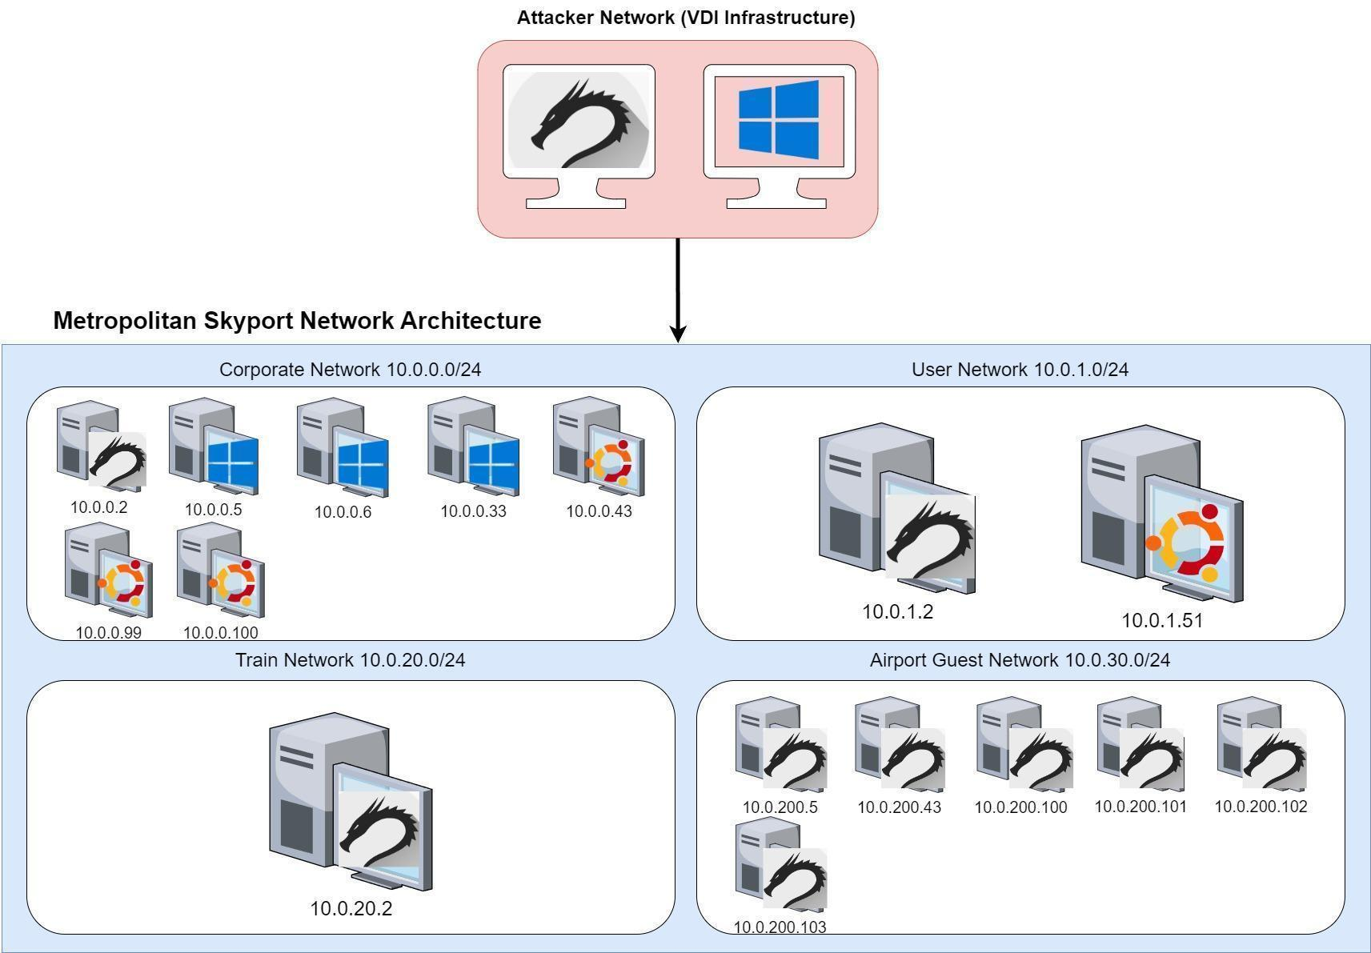

Testing Methodology
Adhering to a consistent methodology is vital when conducting vulnerability assessments. In our assessment, US-Southeast-XX utilized the MITRE ATT&CK framework to model the engagement with Butters Family Farm. This ensures Testing is comprehensive and aligned with real-world adversarial tactics. By structuring the assessment around ATT&CK’s phases, each stage of testing corresponds directly to documented adversary behaviors, providing actionable insights that mirror genuine threat actor methods. Listed Below are the ATT&CK’s phases our team followed in order:
- Reconnaissance & Enumeration – Collect Information on the target within the confines of our scope. Scanning networks and Identifying vulnerabilities that could lead to initial access.
- Exploitation – Exploit discovered vulnerabilities to gain initial access into targeted systems or networks.
- Persistence – Establish a foothold on networks/ systems to maintain access, even in the event of a reboot or attempts at remediation all while remaining undetected.
- Privilege Escalation – Escalate Low level privilege access to administrator or root, enabling further exploitation of network and systems.
- Exfiltration – Extract valuable data from compromised systems while remaining undetected, documenting the process throughout.
- Reporting – Report exploited vulnerabilities, document findings, and suggest remediation steps to the Blue Team to help harden company systems and improve future security posture.

Risk Assessment Methodology
The assessment findings in this report follow the Common Vulnerability Scoring System (CVSS) v3.1 to evaluate the severity of each vulnerability. The CVSS scoring system includes base vulnerability factors as well as temporal and environmental factors. Business impact is further explained in the technical details. The vector string in the risk classification tables contains every metric that is used to calculate the CVSS score, With categories separated with a forward slash (/). The main categories include Attack Vector (AV) which can be assigned with the values N (Network), A (Adjacent), L (Local), and P (Physical). To see all components and their values refer to the CVSS 3.1 specification document.
Severity | CVSS v3.1 Score
Critical | 9.0 - 10.0
High | 7.0 - 8.9
Moderate | 4.0 - 6.9
Low | 0.1 - 3.9
Informational | 0.0

10(ish). Risk Classifications
Severity | CVSS | Vulnerability Name
Critical
High
Moderate
Low
Informational

Assessment Finding
Name of Vulnerability
Risk | Vector | Score
Critical
Affected Scope
- 255.255.255.255 (Domain Name if applicable)
Description
Description of vulnerability.
Technical Impact
Explain the impact that this has on the affected service/machine
Business Impact
Explain the impact that this vulnerability has on the business
Steps to Reproduce
- Include screenshots and explanations of how to reproduce a vulnerability.
Remediation Recommendation
List steps they can take to remediate the vulnerability
References
Include hyperlinks used
END OF FINDING

Name of Vulnerability
Risk | Vector | Score
Critical
Affected Scope
- 255.255.255.255 (Domain Name if applicable)
Description
Description of vulnerability.
Technical Impact
Explain the impact that this has on the affected service/machine
Business Impact
Explain the impact that this vulnerability has on the business
Steps to Reproduce
- Include screenshots and explanations of how to reproduce a vulnerability.
Remediation Recommendation
List steps they can take to remediate the vulnerability
References
Include hyperlinks used
END OF FINDING

Name of Vulnerability
Risk | Vector | Score
Critical
Affected Scope
- 255.255.255.255 (Domain Name if applicable)
Description
Description of vulnerability.
Technical Impact
Explain the impact that this has on the affected service/machine
Business Impact
Explain the impact that this vulnerability has on the business
Steps to Reproduce
- Include screenshots and explanations of how to reproduce a vulnerability.
Remediation Recommendation
List steps they can take to remediate the vulnerability
References
Include hyperlinks used
END OF FINDING

Conclusion
The Butters Family Farm network was deemed to have vulnerabilities of varying degrees, ranging from critical to low. This report includes an analysis comprising levels of risk, detailed explanations, and recommended remediations. Implementing these remediations should be done posthaste, as it will further enhance the security of the Butters Family Farm network to prevent future compromises of confidentiality, integrity, and availability of user data, personal information, and host systems.
Our firm, US-Southeast-X, further recommends a comprehensive follow-up at a later date to ensure the systems with their respective vulnerabilities have been adequately patched and that no new issues have arisen in their place. In addition, we thank Butters Family Farm for this opportunity and we look forward to our new and ever-expanding professional relationship together.

Very Respectfully,
US-Southeast-XX

Appendix A: Tools //CHANGEME
BloodHound: This tool is used to visualize and identify attack paths in Active Directory environment
Burpsuite: An integrated web-application security testing platform centered on an intercepting proxy that lets testers inspect, modify, scan, and automate attacks on HTTP/S traffic
CrackMapExec: A post-exploitation tool that can be used to quickly assess Active Directory domains.
Crackstation: This tool is used to look up tables that are then used to crack password hashes.
Dig: This tool is used to get information from a DNS.
EnumForLinux: A tool for enumerating both Windows and Samba SMB.
GoBuster: A fast directory, file, and DNS brute-forcing tool used to discover hidden paths and subdomains on web servers using wordlists.
Hydra: A network logon cracker used to guess passwords.
LES: A Linux privilege-escalation auditing tool that scans for misconfigurations, weak permissions, and exposed credentials.
LinEnum: Windows privilege-escalation enumeration script that finds misconfigurations, weak permissions, and common escalation vectors.
Linpeas: Linux privilege-escalation script that finds misconfigurations and exposed credentials.
Meterpreter: A Metasploit attack payload that provides the user with an interactive shell and tools.
Metasploit: An exploitation tool with the ability to launch attacks and pivot.
MSFVenom: This tool is a combination of other tools that can be used to create a payload.
MySQL: This tool is used to display database information from a server.
Nmap: Nmap or “Network Mapper” is a free open-source utility that is used for network discovery.
NSLookup: This tool is used to retrieve the records associated with a domain name.
Nitko: A web server scanner that performs comprehensive checks for known vulnerabilities, misconfigurations, and outdated server components.
Putty: An SSH and telnet client that allows a user to connect to another machine
Remote Desktop Connection: This tool allows remote access to another computer with a GUI.
Responder: This tool listens for a specific NETBIOS name and when it is triggered will answer.
SMBClient: This tool can be used to communicate with an SMB server.
Sqlmap: A web server scanner that performs comprehensive checks for known vulnerabilities, misconfigurations, and outdated server components.
Wpscan: A WordPress-focused vulnerability scanner that enumerates plugins, themes, and users and checks them (and site configuration) against a database of known vulnerabilities and common weak credentials.
Wireshark: A network protocol analyzer for capturing and inspecting live network traffic and packet-level details.

Appendix B: Acronyms Used //CHANGEME
AD: Active Directory
C2: Command and Control
DNS: Domain Name System
HTTP: Hypertext Transfer Protocol
LLMNR: Link-Local Multicast Name Resolution
MD5: Message-Digest Algorithm 5
MITM: Man-In-The-Middle
NBT-NS: NetBIOS Name Service
PHP: Hypertext Preprocessor
PLC: Programmable Logic Controller
PoC: Proof of Concept
RDP: Remote Desktop Protocol
ROE: Rules of Engagement
SMB: Server Message Block
SSH: Secure Shell
TLS: Transport Layer Security

Do’s and Dont’s - Delete Before Turning in
- Do include technical evidence that you were able to perform an issue. While this may be different in a professional setting, where you can have multiple deliverables, at CPTC you have one, and we need to be able to reperform what you’ve done or see that you’ve done it clearly.
- ﻿Don’t include unredacted sensitive customer, employee, or intellectual property information in reports. Strive to aim higher than your client, who may have been terrible at storing information securely:
- ﻿Do include references to findings or relevant information to help your audience locate information and solve issues, such as technical links, example commands or code to fix the issue, etc.
- ﻿Don’t use hyperlinks without the full link, as reports are often printed or converted to PDF.
- Do use professional, third person, language and provide an explanation for everything you include, a screenshot on its own doesn’t communicate as much as one with context.
- Don’t personally blame the client for any issues identified. Avoid second-person wording, such as phrases beginning with the word “you”.
- Do include an executive summary, and make sure it’s appropriate for the intended audience and level.
- Don’t include excessive technical detail in an executive summary. This audience may not know what an IP address is, let alone care about it. Excessive technical detail will often confuse the reader and cause more questions and concerns than necessary.
- Do recognize that your clients will have questions about your findings, and you will be asked to perform some activities within client environments to validate their remediation. Clients who partner with you throughout the testing process are the ones you will want to work with year after year and will often want to work with you.
- Don’t just show the client how they messed up, show what they did well to give them some credit. A positive start can make a massive overall difference in how your message is received.
- Do always seek to learn and improve. The information security field is a relatively small, tight-knit community - and your reputation for quality work and integrity are incredibly valuable.
- Don’t forget to proofread and spell check your report. These errors undermine your credibility and make your overall message less professional.
- Do provide reports in formats where they cannot be easily modified. Customers may want certain findings omitted from reports, but you should only document the resolution of these findings once they’re remediated if you have validated the remediation and are still within the timeframe of your engagement. In general, findings should never be removed from a report as without the engagement they would have not been identified and resolved.
- Don’t share your report with a client in an insecure way. Malicious actors would love to get their hands on one, documentation on all the weaknesses will save them effort.

Pics

